AI-Driven Smart Disaster Relief Resource Allocation and Volunteer Coordination Platform

Field | Details
Submitted By | Surya Krishna Teja Yandra
Register No. | 192425065
Department | CSE-AI
Subject | Software Engineering
Faculty | Dr. Latha R.
College | SIMATS Engineering
Academic Year | 2024–2028

AI-Driven Smart Disaster Relief Resource Allocation and Volunteer Coordination Platform
Industry Context
During natural disasters and humanitarian emergencies, effective coordination of relief resources
and volunteers is critical for minimizing casualties and accelerating recovery. Government agencies,
non-governmental organizations (NGOs), and emergency response teams require intelligent
platforms capable of managing supplies, personnel, and logistics efficiently. AI, GIS, cloud
computing, and mobile technologies enable real-time coordination and data-driven disaster
response.
Problem Statement
Disaster relief operations often suffer from inefficient distribution of food, medicine, shelter
materials, and emergency personnel due to fragmented communication and lack of centralized
coordination. Manual resource allocation can lead to duplication, shortages, and delayed assistance.
An AI-driven disaster relief management platform should analyze disaster severity, affected
population, available resources, volunteer locations, and transportation networks to optimize relief
distribution. The system should provide real-time dashboards, automate volunteer assignments, and
support emergency decision-making to improve disaster response effectiveness.
Objectives
1. Manage disaster relief resources digitally.
2. Coordinate volunteers efficiently.
3. Prioritize relief distribution using AI.
4. Monitor resource availability in real time.
5. Optimize transportation routes.
6. Generate emergency operation dashboards.
7. Improve inter-agency coordination.
8. Enhance disaster response planning.
Expected Outcomes
1. Faster disaster relief distribution.
2. Improved volunteer coordination.
3. Efficient resource utilization.
4. Reduced response time.
5. Better emergency decision-making.
6. Increased transparency in relief operations.
7. Enhanced community resilience.
8. Improved humanitarian assistance effectiveness.

AI-Driven Smart Disaster Relief Resource Allocation and Volunteer Coordination Platform

1. System Requirement Analysis
1.1 System Objectives
The main objectives of the proposed system are:
- Manage disaster relief resources digitally.
- Coordinate volunteers efficiently.
- Prioritize relief distribution using AI.
- Monitor resources in real time.
- Optimize transportation routes using GIS.
- Generate emergency dashboards.
- Improve coordination between government agencies and NGOs.
- Support faster and better disaster response.

1.2 Functional Requirements
- User Registration and Login
- Disaster Reporting
- Resource Management
- Volunteer Management
- AI-Based Resource Allocation
- AI-Based Volunteer Assignment
- GIS Route Optimization
- Real-Time Resource Tracking
- Notifications (SMS/Email)
- Dashboard and Reports
- Feedback Management
- Admin Management

1.3 Non-Functional Requirements
- High Performance
- Secure Authentication
- Data Encryption
- High Availability (24×7)
- Reliability
- Scalability
- Easy Maintenance
- User-Friendly Interface

1.4 Quality Attributes
Quality Attribute | Description
Scalability | Supports increasing users and disaster events.
Maintainability | Modular services simplify updates.
Reliability | Continuous operation with backup and recovery.
Availability | Cloud-based 24/7 access.
Performance | Fast AI processing and response.
Security | Authentication, authorization, and encrypted data.

2. Selection of Software Architecture
Selected Architecture
Hybrid Microservices + Event-Driven Architecture
Reason for Selection
This system involves multiple independent services such as resource management, volunteer coordination, AI prediction, GIS routing, and notifications. A Hybrid Microservices architecture allows each service to work independently, while Event-Driven Architecture enables instant updates whenever a disaster is reported or resources change.
Advantages
- Independent deployment of services
- High scalability
- Easy maintenance
- Real-time communication
- Fault isolation
- Supports cloud deployment

3. Software Architecture Diagram
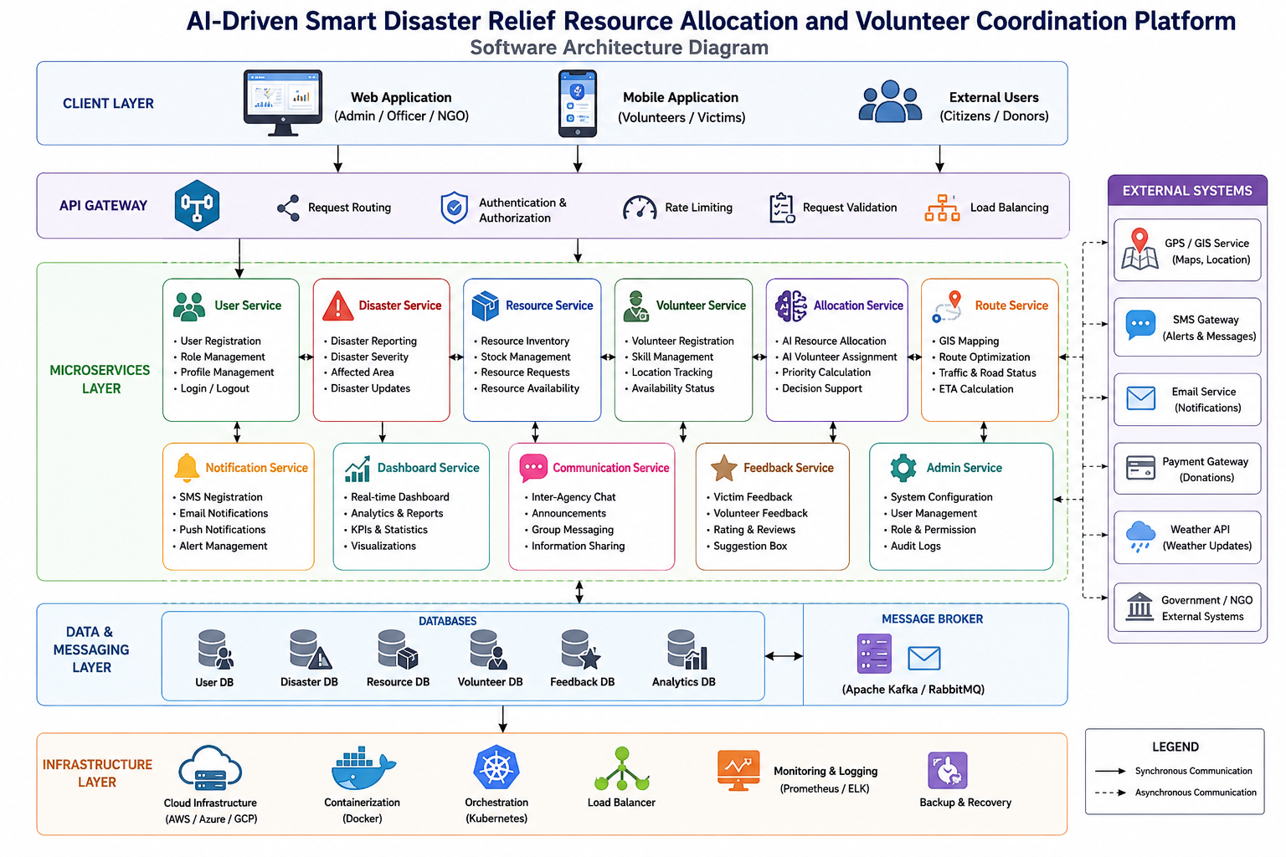

4. Components and Their Interactions
1. Web/Mobile Application
- User interface for all stakeholders.
- Displays dashboards and reports.

2. API Gateway
- Receives all requests.
- Authenticates users.
- Routes requests to appropriate services.

3. User Service
- User registration
- Login
- Role management

4. Disaster Service
- Receives disaster reports.
- Stores disaster details.
- Sends events to AI Engine.

5. Resource Service
- Maintains food, medicine, shelter inventory.
- Updates stock availability.

6. Volunteer Service
- Registers volunteers.
- Tracks volunteer locations.
- Assigns volunteers using AI.

7. Dashboard Service
- Displays analytics.
- Shows disaster statistics.
- Generates reports.

8. Notification Service
- Sends SMS
- Sends Email
- Push Notifications

9. AI Recommendation Engine
- Predicts resource requirements.
- Prioritizes victims.
- Assigns volunteers.
- Optimizes resource allocation.

10. GIS Route Service
- Finds shortest routes.
- Avoids blocked roads.
- Calculates delivery time.

11. Database
Stores:
- User Information
- Disaster Data
- Resource Inventory
- Volunteer Information
- Reports
- Feedback

12. External Systems
- Google Maps API
- GPS Services
- SMS Gateway
- Email Server

System Workflow
- User reports a disaster.
- API Gateway validates the request.
- Disaster Service stores disaster details.
- AI Engine analyzes severity.
- Resource Service checks available supplies.
- Volunteer Service assigns nearby volunteers.
- GIS Service finds the best delivery route.
- Notification Service alerts volunteers.
- Dashboard displays real-time updates.

5. Quality Attribute Analysis
Scalability
- Microservices allow independent scaling.
- Cloud auto-scaling supports high traffic.

Security
- JWT Authentication
- HTTPS Communication
- Data Encryption
- Role-Based Access Control (RBAC)

Performance
- Independent services reduce processing time.
- API Gateway balances requests.
- AI processes data efficiently.

Reliability
- Backup Database
- Error Recovery
- Fault Isolation
- Continuous Monitoring

Maintainability
- Modular services
- Easy debugging
- Independent updates
- Clean API interfaces

Availability
- Cloud deployment
- Load balancing
- Multiple service instances
- 24×7 availability

6. Justification of Architectural Decisions
Why Hybrid Microservices + Event-Driven?
- Supports real-time disaster response.
- Independent services improve flexibility.
- Easy integration with AI, GIS, SMS, and cloud.
- Faster deployment and maintenance.
- Suitable for large-scale disaster management.

Trade-Offs
Advantages | Disadvantages
High scalability | Higher deployment complexity
Independent services | More monitoring required
Fault isolation | Increased network communication
Easy future expansion | Higher infrastructure cost

Future Enhancements
- Drone-based relief monitoring.
- IoT sensor integration for disaster detection.
- Predictive AI for disaster forecasting.
- Blockchain for secure relief tracking.
- Multilingual voice assistant.
- Offline mobile support for low-network areas.

Conclusion
The Hybrid Microservices + Event-Driven Architecture is the most suitable design for the AI-Driven Smart Disaster Relief Resource Allocation and Volunteer Coordination Platform. It provides scalability, reliability, security, and maintainability while enabling real-time coordination among government agencies, NGOs, volunteers, and disaster victims. This architecture also supports future integration with advanced AI, IoT, GIS, and cloud technologies, making it a robust and extensible solution for modern disaster management.

